Name: hadiya Naeem
Roll no: su92- bsaim-f25-078
Section: bsai -3b

Lab title
Comparison of minimax and alpha-beta puring on binary game
Minimax algorithm
Minimax explore the all branches, max look for large child (large vlue), where mini look for small child (small value)
Hand trace minimax:
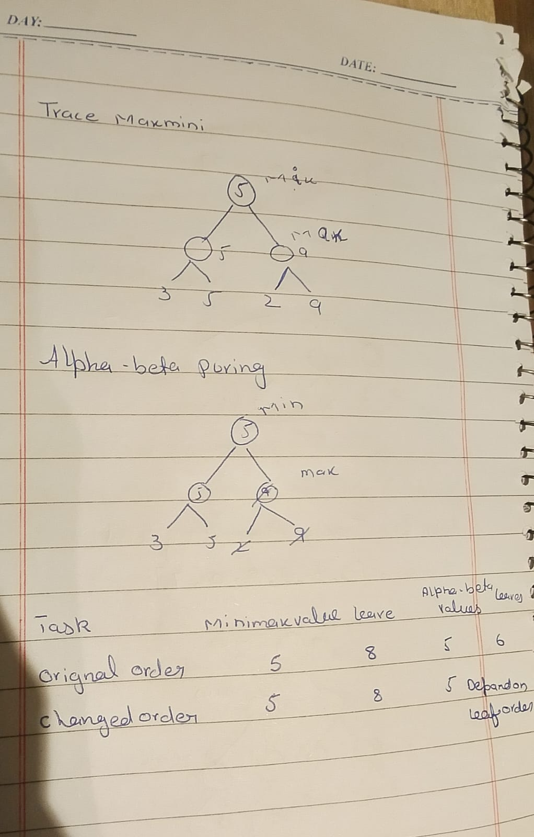
Minmax code :
# Reorder branches and observe how pruning changes while the Minimax value remains the same
import math
# add leaf counter
minmax_count =0
# Maximizing player can get
def minimax(curDepth, nodeIndex, maxTurn, scores, targetDepth):
# Base case: targetDepth reached
# now we add global function to change the variable inside the function
global minmax_count
if curDepth == targetDepth:
minmax_count += 1
return scores[nodeIndex]
if maxTurn:
return max(
minimax(curDepth + 1, nodeIndex * 2, False, scores, targetDepth),
minimax(curDepth + 1, nodeIndex * 2 + 1, False, scores, targetDepth)
)
else:
return min(
minimax(curDepth + 1, nodeIndex * 2, True, scores, targetDepth),
minimax(curDepth + 1, nodeIndex * 2 + 1, True, scores, targetDepth)
)
# Driver code
scores = [7, 3, 5, 2, 9, 0]
treeDepth = math.ceil(math.log2(len(scores)))
# Pad scores to make a complete binary tree
scores += [0] * (2**treeDepth - len(scores))
print("The optimal value is:", end=" ")
result = minimax(0, 0, True, scores, treeDepth)
print("minmax value :", result)
print("leaved checked:", minmax_count)

output:
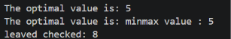
Alpha-beta puring:
It helps us to skipping the branches that cannot change the final decision, where minimax takes possible values and take too much time it make it easy and efficient.
Alpha beta screenshort:
# Reorder branches and observe how pruning changes while the Minimax value remains the same

# for comparison
import math
# add leaf counter
alphabeta_count = 0

def alphabeta(depth, index, maxTurn, scores, target, alpha, beta):
global alphabeta_count
if depth == target:
alphabeta_count += 1
return scores[index]

if maxTurn:
value = float('-inf')

for i in range(2):
value = max(
value,
alphabeta(depth + 1, index * 2 + i, False,
scores, target, alpha, beta)
)

alpha = max(alpha, value)

if alpha >= beta:
break

return value

else:
value = float('inf')

for i in range(2):
value = min(
value,
alphabeta(depth + 1, index * 2 + i, True,
scores, target, alpha, beta)
)

beta = min(beta, value)

if alpha >= beta:
break

return value
#we reverse values in scroes
scores = [ 9, 2, 5, 3, 9, 2, 5, 3]
depth = int(math.log2(len(scores)))

result =(alphabeta(
0, 0, True, scores, depth,
float('-inf'), float('inf')
))
print("alpha-beta value :", result)
print("leaved checked:", alphabeta_count)

output :
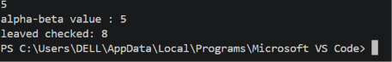

Comparison table:
Task minimaxvalue leaves alpha-beta values leaves
Original order 5 8 5 6
Changed order 5 8 5 depend on leaf order

Edge case test:
It uses equal leaves [1,1,1,1,1,1,1] both algorithm returns 5.

6. Interpretation
Minimax and Alpha-Beta Pruning return the same optimal value of 1 for the tested tree. Minimax evaluates all 8 leaves, while Alpha-Beta can skip leaves when the bounds prove they are unnecessary. The original order evaluates 6 leaves, whereas the reordered cases shown in the code evaluate 8. Therefore, branch ordering affects pruning efficiency but not the final Minimax value.

